Michael Smith

Rebecca Cressman

**Possible Designs for Tensioned Cable Experiments**

Having successfully accomplished the free hanging experiments, it is necessary to move forward into the fixed boundary rod vibrations. These tests will alter the vibratory nature of the cables and will more accurately represent how sound travels in the Newport Bridge. A number of options were considered for tensioning the cable. Bellow these options are enumerated upon.

Bracket Fixed:

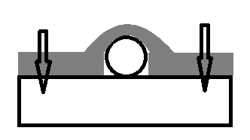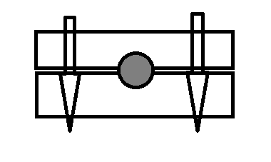

Above is two concepts for securing individual or bundled cables. In the first drawing a rounded metal bracket is affixed on top of the cable. In the second drawing two solid supports encase the cable. The arrows represent were screws or fasteners would go. Both designs rely on large pressure applied around the cable to keep it from sliding under tension. This method is less preferred.

Mock Anchorage:

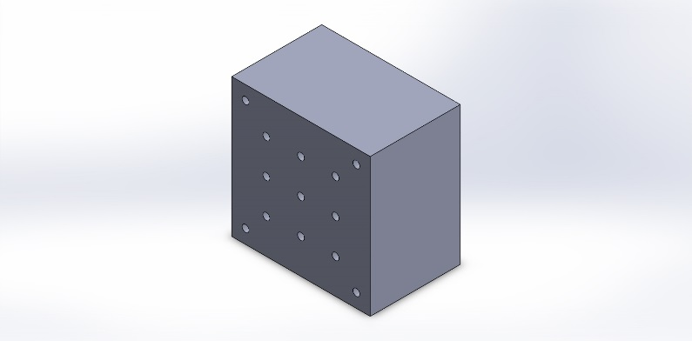

In this design, a concrete anchorage similar to the one used in the bridge would be made. There would be 9 cable holes that would provide the ability for individual and group testing. The cable would be run through the block and a fastening mechanism would be applied to prevent the cable from slipping

There are three designs considered for preventing the cable from slipping back through the block. See Below:

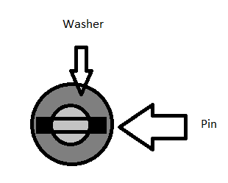In this design, a pin placed in a hole drilled through the rod prevents the rod from slipping back by running up against a washer.

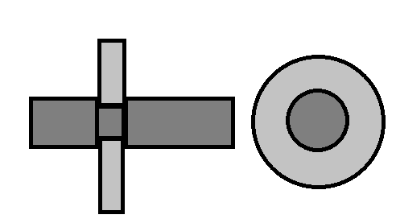In this design, the rod’s diameter is decreased slightly at a point before the end. In this groove one to two C-clips are placed and they prevent slippage in the rod through the block.

The last design is to thread the end of the rod. This will allow a washer and nut combination to be used. The washer will distribute the weight and prevent slippage and the nut will prevent the rod from sliding out of the washer or anchorage.

It was decided that at this moment the most viable option is to thread the end of the rod. After threading, a washer and nut combo can be attached directly to the concrete block. A second option that has been detailed below, is to create a bearing plate. This would forgo the need for the washer and would closely mimic the bridge design.

